CST 229 – Lecture 3
Wilsonville, Fall 2017
Ch 8-10: Moore, Mealy, regular and non-regular languages, pumping lemma

More Machines (Pun Intended)
Moore Machines
DFA that print output when they enter a state
Invented by E. F. Moore in 1956

- Finite set of states
- Input alphabet
- Output alphabet
- Transition table
- Output table (which output letter to print when state is entered)

Note: No final states! The point is not to accept a string, but to translate it.

Example:
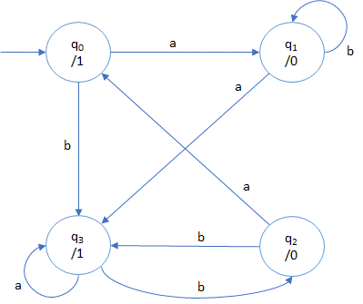
Input Alphabet: {a, b}
Output Alphabet: {0, 1}

Transition/Output Table:
State | Output | a | b
q0 | 1 | q1 | q3
q1 | 0 | q3 | q1
q2 | 0 | q0 | q3
q3 | 1 | q3 | q2

Note: Remember that output is printed
when the state is entered

Input: abab
Output: 10010

Mealy Machines
NFA that print when transition from one state to another
Invented by G. H. Mealy in 1955

- Finite set of states
- Input alphabet
- Output alphabet
- Transition table (including which output letter to print when transitioning)

Example:
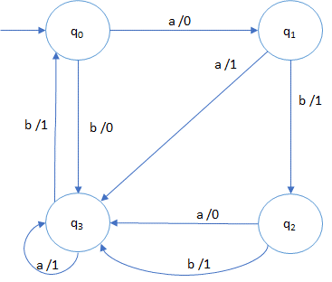
Input Alphabet: {a, b}
Output Alphabet: {0, 1}

Transition Table:
State | a | b
q0 | q1 /0 | q3 /0
q1 | q3 /1 | q2 /1
q2 | q3 /0 | q3 /1
q3 | q3 /1 | q0 /1

Input: aaabb
Output: 01110

Mealy = Moore
They are essentially equivalent in capability
We can translate between them
For each Mealy machine, we can construct the equivalent Moore machine
For each Moore machine, we can construct the equivalent Mealy machine

It comes down to finding the right set of states/transitions that print when expected

Generic State Machines
To get the full power of state machines, combine Mealy and Moore concepts and add…

- States can have entry and exit actions
- Transitions can have actions
- States can have embedded state machines (sub-states)
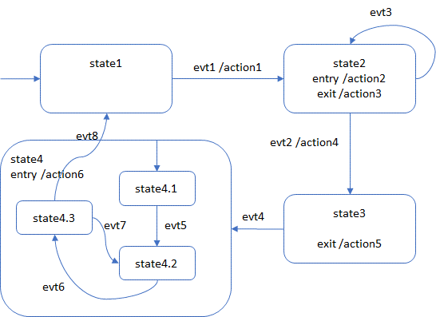

Typical use includes designing the state behavior of a class, then implementing the class from that design

Example of CheckBox GUI class

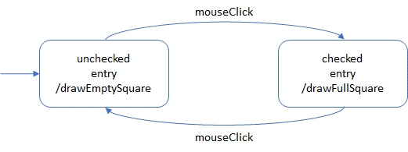

Regular / Non-Regular Languages
Ch 9 & 10

Regular Languages are all languages that can be…
Defined by Regular Expressions (RE)
Accepted by Finite Automata (FA)

Not all languages are Regular Languages
They are called Nonregular Languages

Why can RE and FA not handle all languages?

Try this example:
L = { a^{n}b^{n}, where n = 0, 1, 2… }
L = { λ, ab, aabb, aaabbb, … }

To be a Regular Language, it would need an RE that defines it
How would we construct an RE for this?
If n is any of the allowed values, say 3, we can construct an RE, like “aaabbb”
But what if n can be two of the values, say 2 and 3, then “aabb | aaabbb” maybe?
Remember, RE’s must have a finite set of rules, so just using |’s is not going to work
How about “a*b*”? That leads to strings, like “aaabb” that are not in the language
Positive-closure suffers the same fate as Kleene-closure here
We’re out of RE operators, so we can’t do it and this is not a Regular Language

How do we know which languages are regular and which nonregular?

Pumping Lemma
Theorem 13, pg. 190
Let L be any regular language that has infinitely many sentences. Then there exist some three strings x, y, and z (where y is not the null string) such that all the strings of the form
xy^{n}z for n = 1 2 3 …
are sentences in L.

What this means, is that any regular language with inifite sentences, must have some place in the language where there is an inifite repetition: a Kleene or Positive closure

For this to work as definition of a regular language, the language must accept strings where that can be repeated infinitely

If there is any limit on that repitition, then it is not a Regular Language

There are lot’s of Nonregular Languages, that are very useful
We’ll learn how to define and accept them in upcoming lectures

